ACCUMULAtoR

E-AGLE Trento Racing Team

Università degli studi di Trento

Via Fortunato Zeni 8, Rovereto, Italy

Energus module 6p

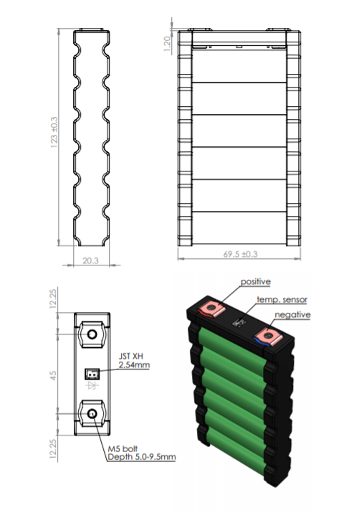

Brusa charger for the accumulator

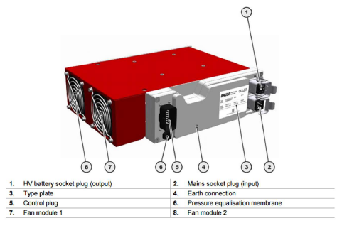

Powertrain render: two Bamocar Inverters, battery pack, cooling collector, two Emrax DC motor

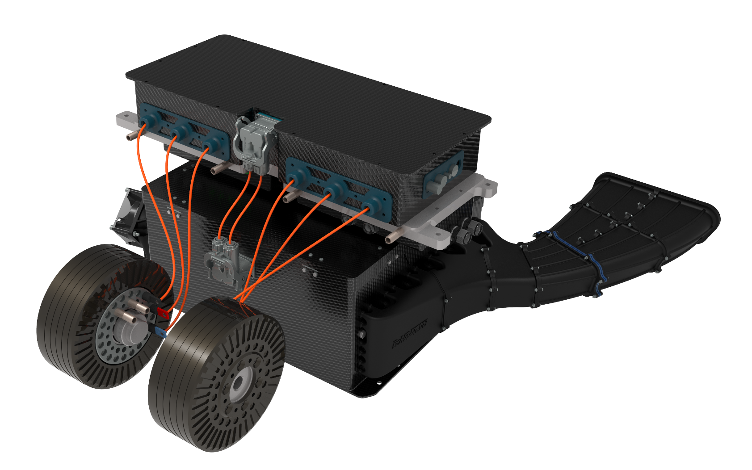

Internal view of battery pack

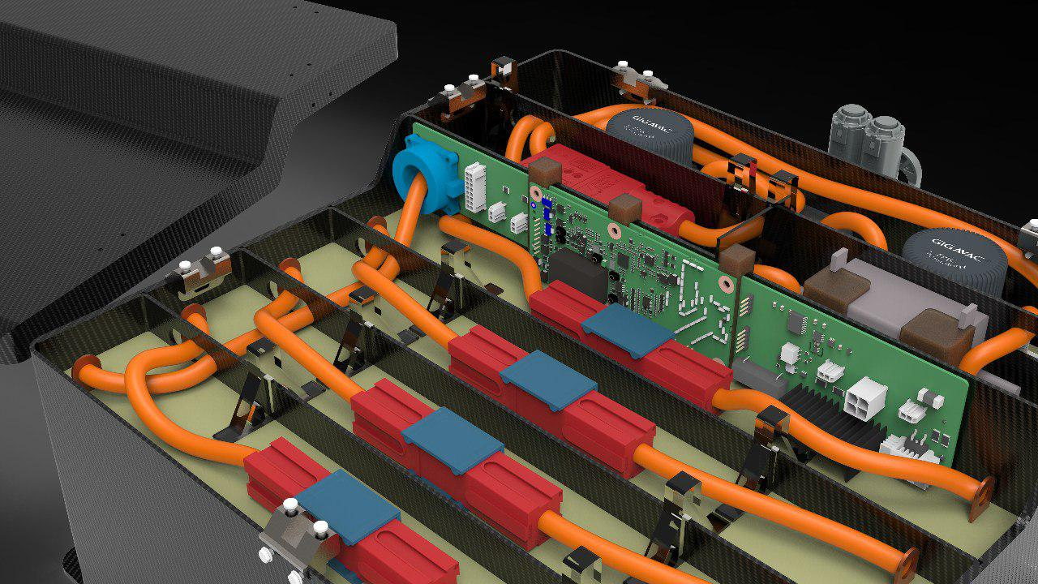

Mainboard

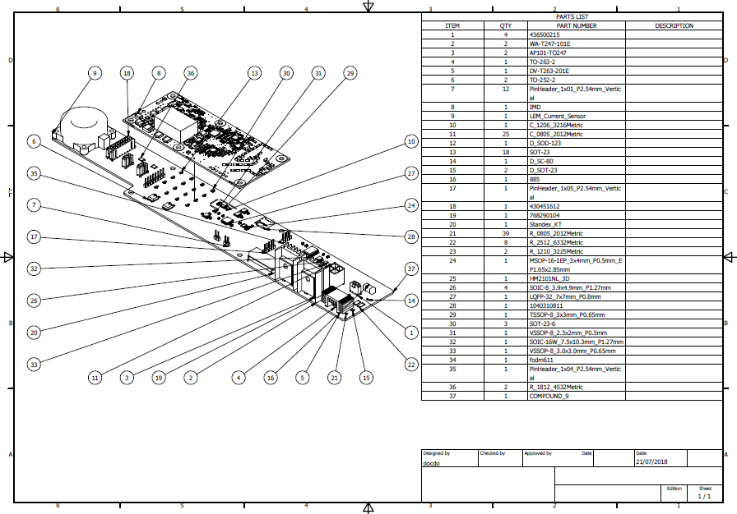

Cell board

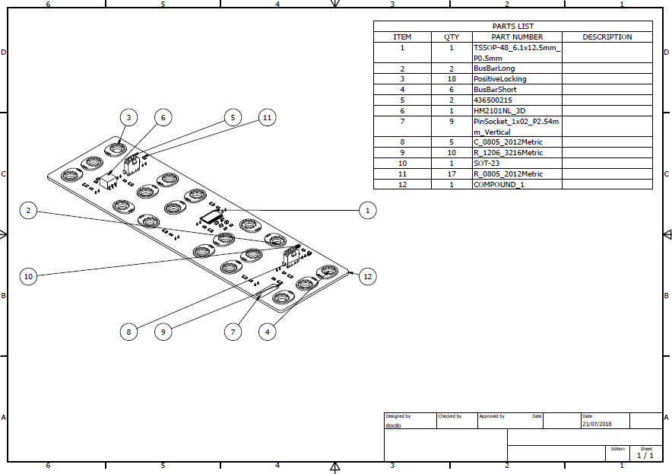

LTC main integrated of the cellboard

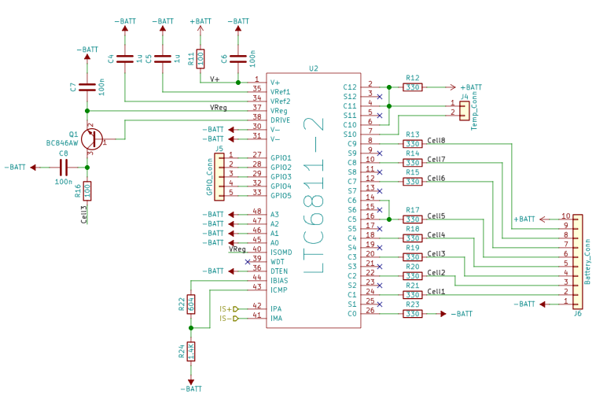

Exploded of HV case

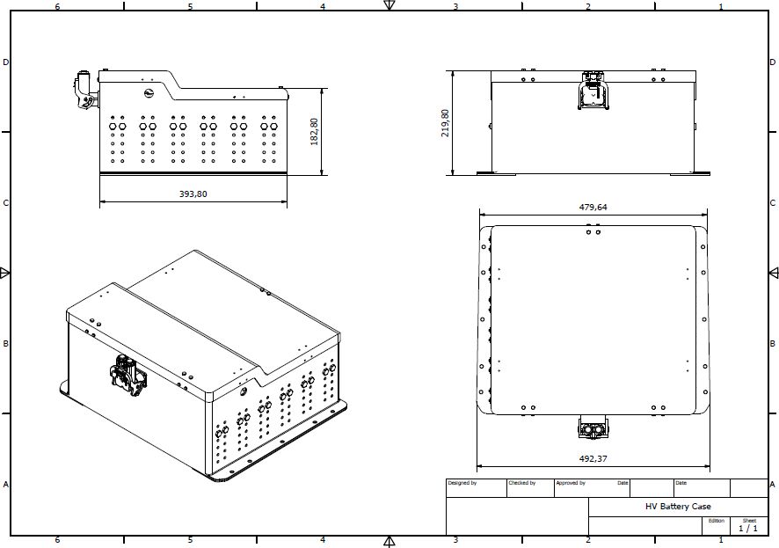

BMS basic schematic

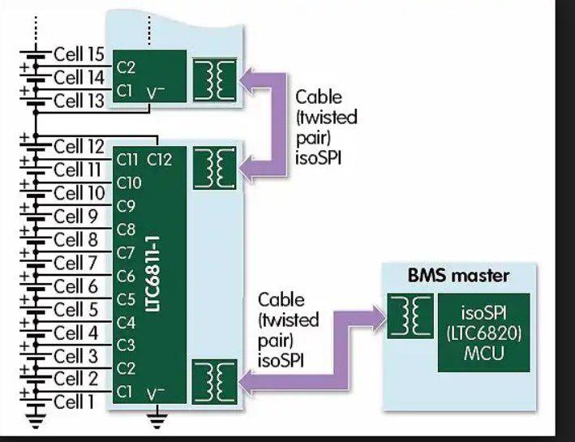

**HV BATTERY PACK DESIGN**

Our first year battery pack was designed choosing Energus Energy Solution as supplier for battery modules, each module is composed by six Sony VTC5 battery in parallel.The configuration of battery pack was 120s6p for a total pack voltage of 504 V and 6,7 Wh.

The design process of the new battery pack was born consequently of deep analysis of the performances of the first year battery pack related to the endurance session.

By reducing the number of series to 108 (454,6 V 5,6 kWh), the use carbon fiber material to realize the HV case and the development of a new BMS allow to achieve better performances, thanks to the weight reduction (46kg).

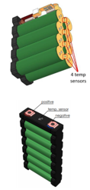 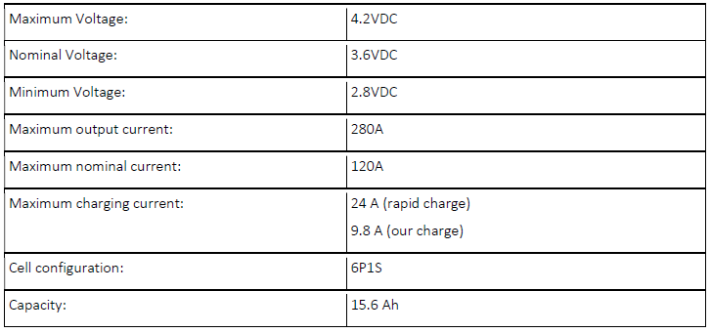

Mechanical design

2016 battery pack vs 2018 battery pack

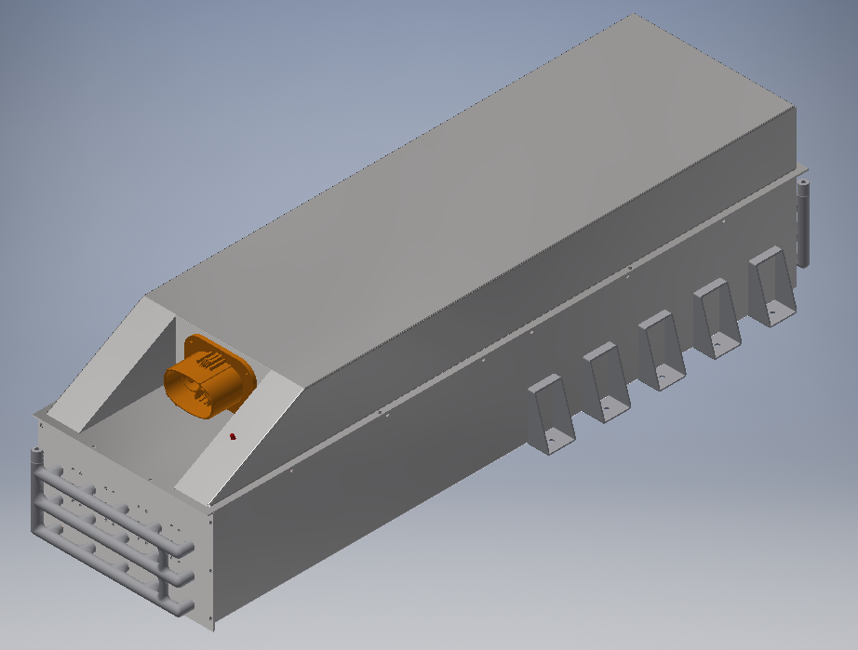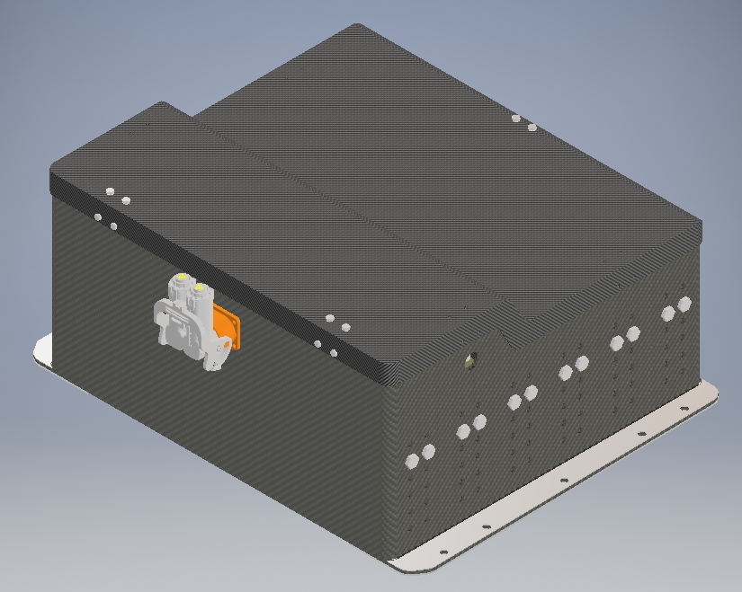

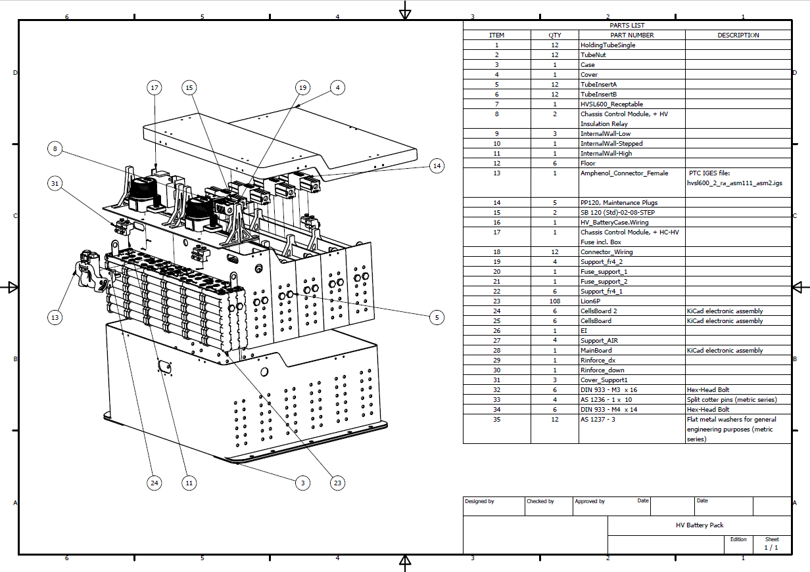

From Stainless Steel to **Carbon Fiber**:

* Weight reduced more than **-30kg** (compared with Chimera)
* Stronger
* Material fire resistant **UL94-V0**
* **No welded** → No thermal deformation



Carbon test results **3 points bending test**:

* Floor:
  + 8 layers T800 twill, layer alternate 0°, 45° → best graphic result for this test among others mechanical test, deferred by the different disposition of layers
  + brought to rupture

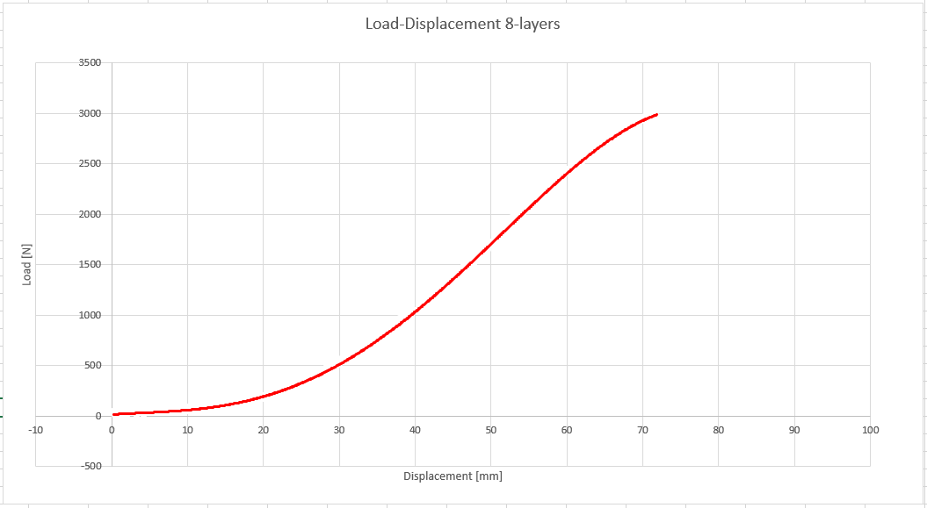

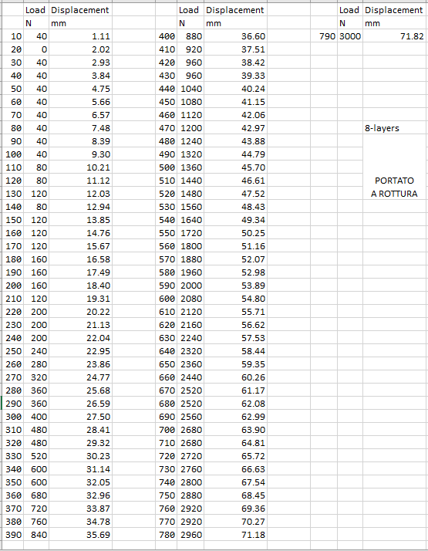

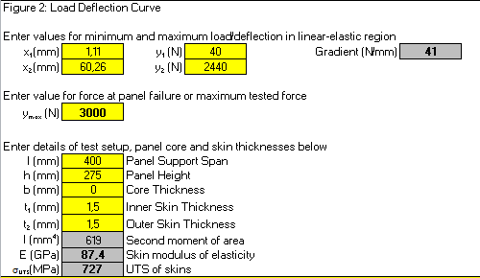

* External walls, Internal walls and Cover:
  + 5 layers T800 twill, layer alternate 0°, 45° → best graphic result for this test among others mechanical test, deferred by the different disposition of layers
  + NO brought to rupture

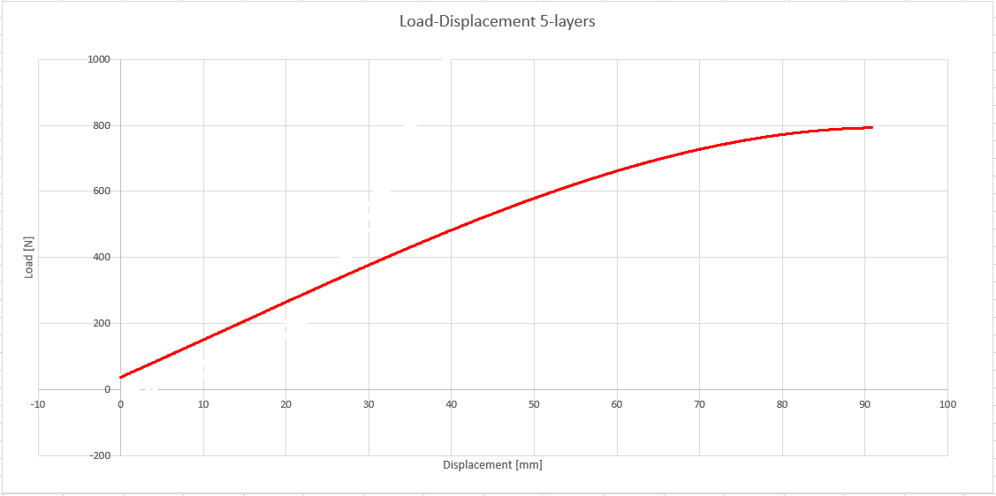

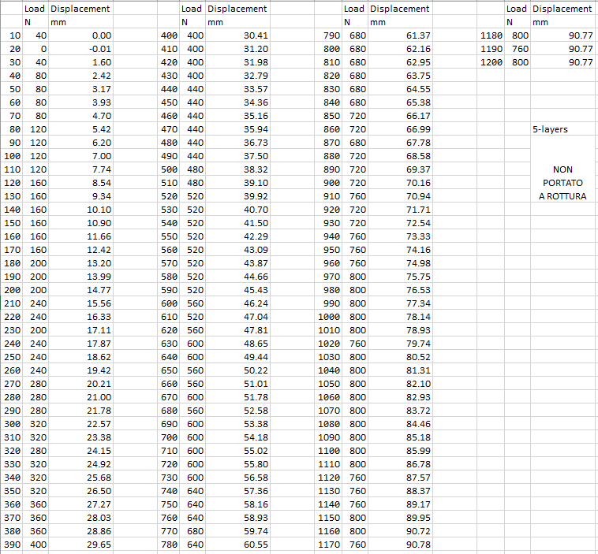

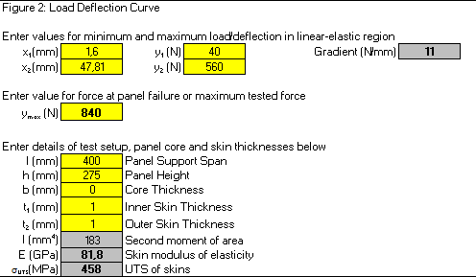

Carbon test results **shear test**:

* Floor:
  + 8 layers T800 twill, layer alternate 0°, 45° → best graphic result for this test among others mechanical test, deferred by the different disposition of layers
  + 3mm thickness

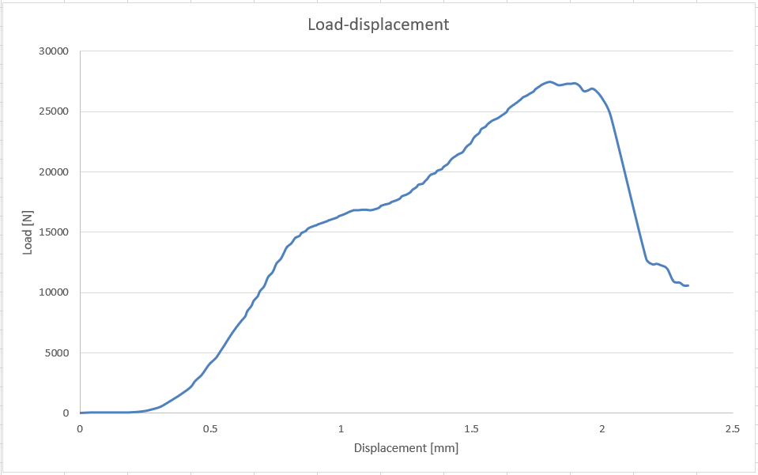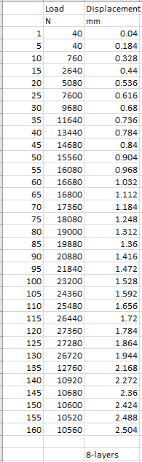

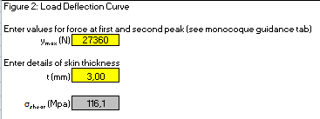

* External walls, Internal walls and Cover:
  + 5 layers T800 twill, layer alternate 0°, 45° → best graphic result for this test among others mechanical test, deferred by the different disposition of layers
  + 2mm thickness

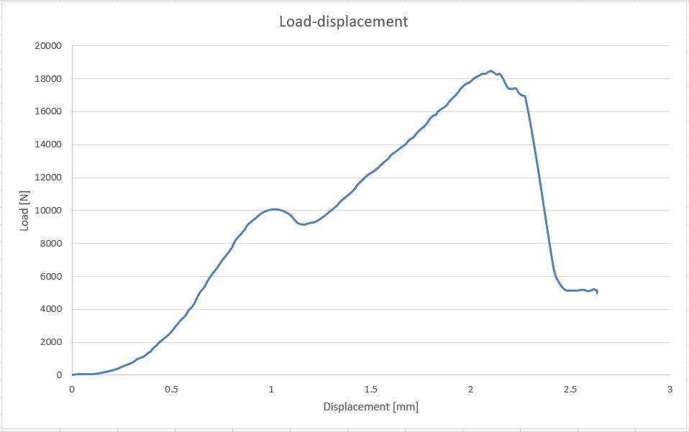 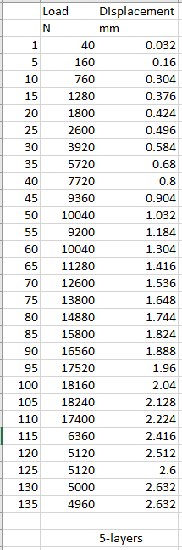

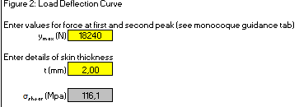

**New assembly** from rear to under chassis in order to:

* Minimize space **in according with chassis optimization**
* Centrate and **lower center of gravity**
* **Have more space** in the back wheels for engine motors

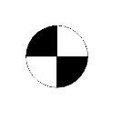

In according with rules:

* **40g** in the longitudinal direction

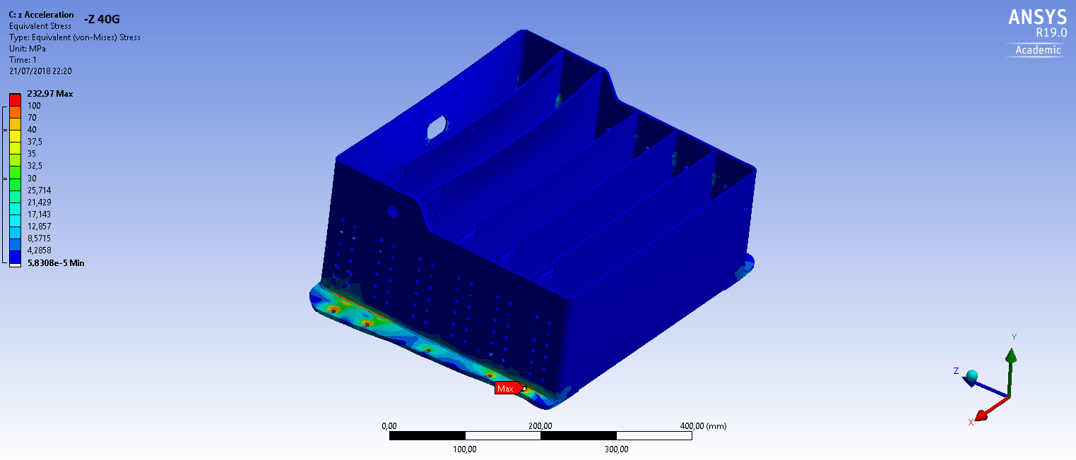

* 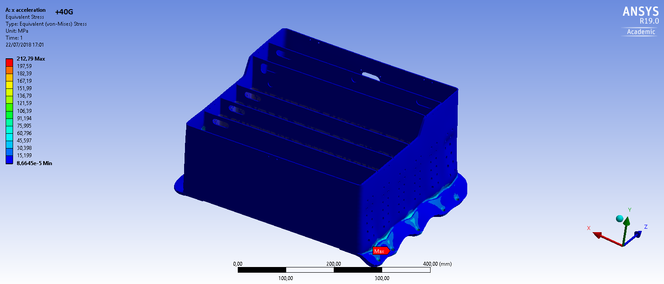**40g** in the lateral direction
* **20g** in the vertical direction

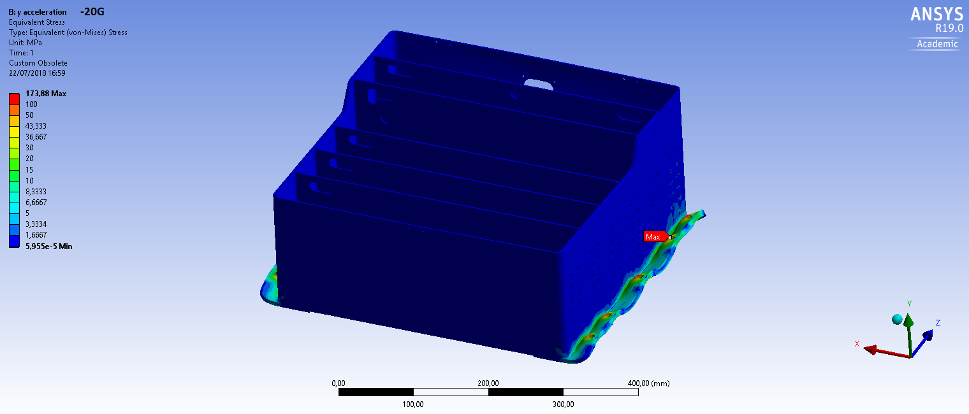

Other specific features:

* **Pressure relif valve** to prevent high-pressure in the container
* **Copper** inside because case must be conductive
* Materials fire resistant in according to **UL94-V0**
* **12kg for each section** must be respected

Attachment points to the chassis:

* **carbon case support**
* hardened with **steel** backing plates to **reduce chassis vibrations and Von Mieses stress** (in particular bending stress) that **reduce deformation** when load is applied
* **20kN** in any direction simulated by Inventor 2018
* **1,5*D** respected for each hole
* **10 holes** for 47kg in order to **improve the** **disposition of cargo**



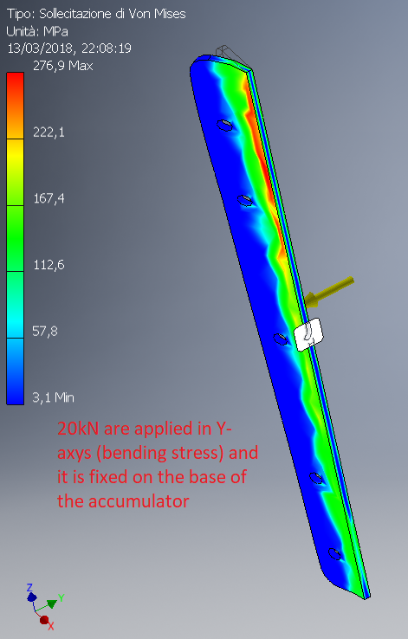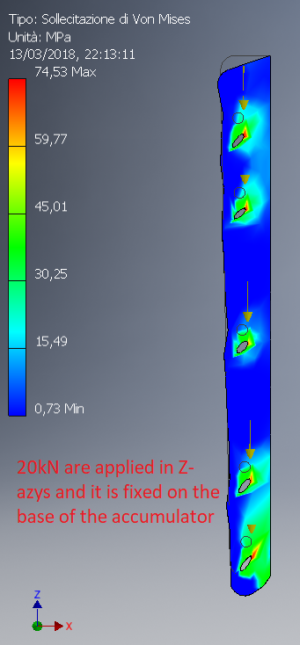

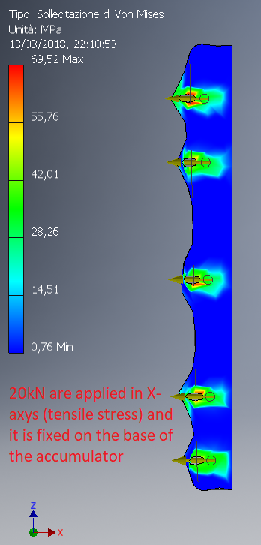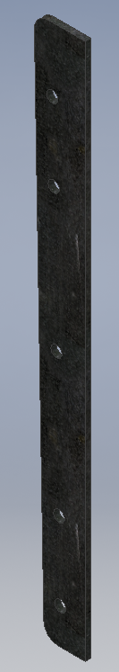

Carbon fiber tube and aluminium bolts:

* **Easy way to install** and remove to fix cells
* Lighter and stronger
* **Reduces case vibrations**
* No welded→ new system to **join different materials**

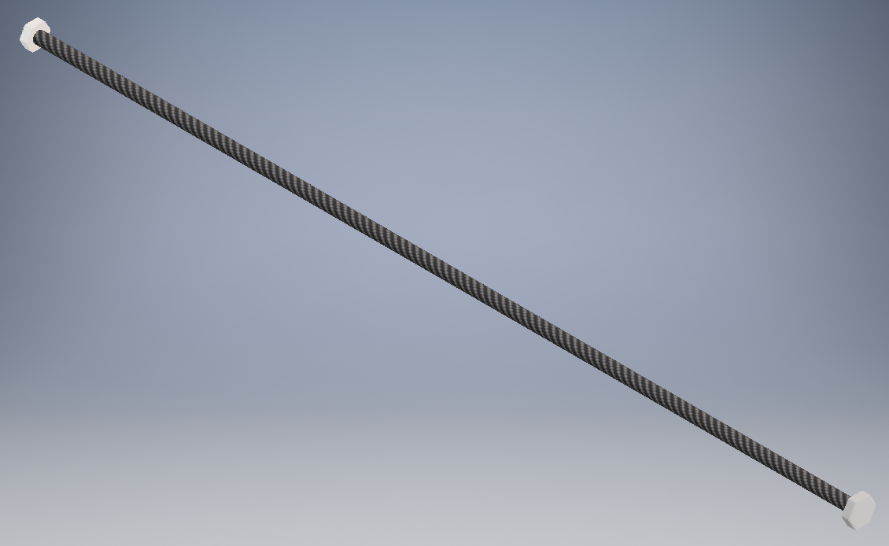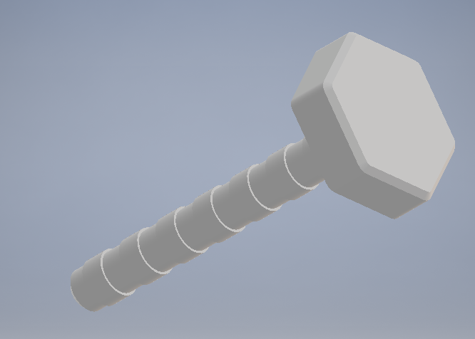

**144** holes on external vertical walls:

* reduces **weigth**
* **doesn’t influence simulation** because 20g and 40g are downloaded on the case support
* **cools batteries**



Cover support:

* Aluminum to reduce weigth
* **Easy to fix** to the case

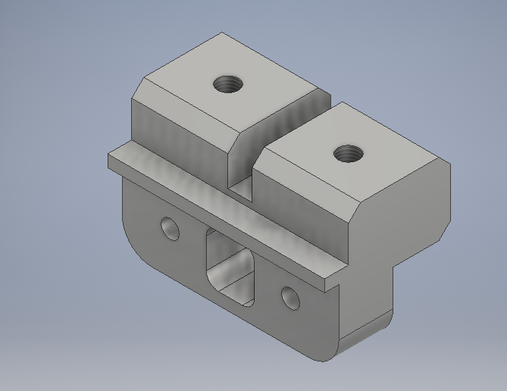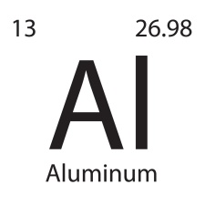

**MDF Mold**:

* High quality-cost ratio
* **Easy machinability**

Case and cover Mold

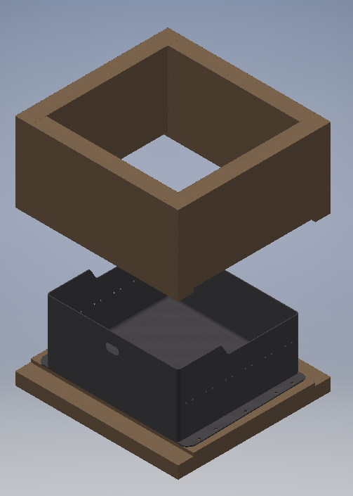 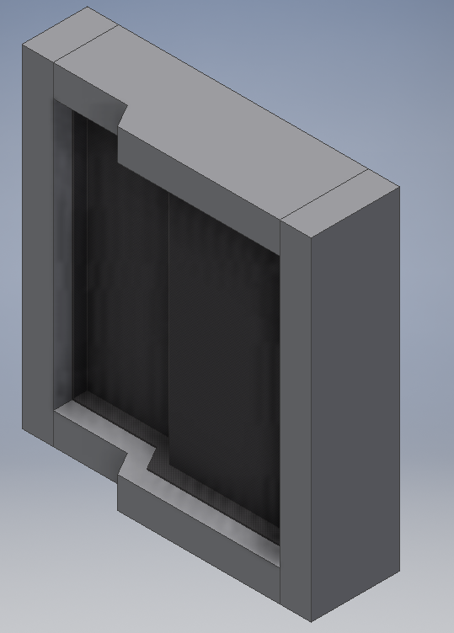

Battery monitoring sistem design

Project planning

In our first year HV battery pack we adopted the Orion battery management system solution. The BMS had a centralized architecture based on Linear chipsets. It provided us the information about temperature and voltage of each modules including under/over voltage/current/temperature detection. The case was composed by steel. The utility software, also provided by Orion, allow to tweak some parameters.

The design process was born by the idea of realizing a custom battery management system designed in synergy with our accumulator solution. This new design is characterized by an hybrid architecture that allows us to achieve a consistent weight and dimensional reduction. The hybrid architecture allows us to overcome the limitations in data transfer and communication of the Orion BMS.

Architecture

The BMS is based on the LTC6804-2 cell stack monitoring IC and a

STM32 microcontroller. There are 12 ICs each one of the monitoring 9 cells and communicating

over an IsoSPI interface. The IsoSPI interface is designed to provide galvanic isolation between

the TS and the GLVS using small pulse transformers and a floating voltage bus between the TS

and the control circuit. All the TS monitoring is done one separated boards for each segment

which are also separated from the main microcontroller board, only the floating bus connects

them together. For the pack voltage sensing a digital isolator is used paired with an isolated

DC/DC converter to supply the ADC.

Monitoring system and shutdown circuit

**The** Main board communicates through **an** isolated SPI protocol to other 12 Cell boards that retrieve information about voltage and temperature of each modules.The MCU of the main board is STM32f348K8 and has the aim of sampling the data of the cell boards, the data of the current sensor and it manages the shutdown circuit. The temperature sensors are Zener diodes purposely made to provide temperature reading with a 1°C accuracy. Each module contains multiple temperature sensible Zener diodes mounted in direct contact

with the negative terminal busbars in such a way that each cell within the module is monitored.

 *Location of Temperature Sensors*

Each cell tap on the PCB is in direct contact with the busbar of the cell, with the contact pressure

provided by the screw which holds the busbar too. Each tap is individually fused with a Fast

Acting 2 Ampere SMD fuse (datasheet). A 2 Amp fuse has been selected so that it doesn’t

interfere with the balancing circuitry which can go up to 1 Amp of current.

Wherever the power train is powered on, the MCU loops until the voltage of the Battery pack is equivalent to the voltage of the inverter exploiting the precharge circuit. As soon it occurs, the Air closed the circuit and the current can flow through inverters.

An additional security check is performed whenever the vehicle goes in RUN mode. Each 10 ms cell data are sampled and an evaluation is done in order to check under/over voltage/temperature/current.

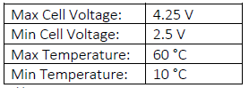

Whenever any of these cases occurs the shutdown circuit open the AIRs, interrupting HV current erogation, preventing any possible damage.